SELECT STATEMENTS
1.Structure of DEPARTMENT Table
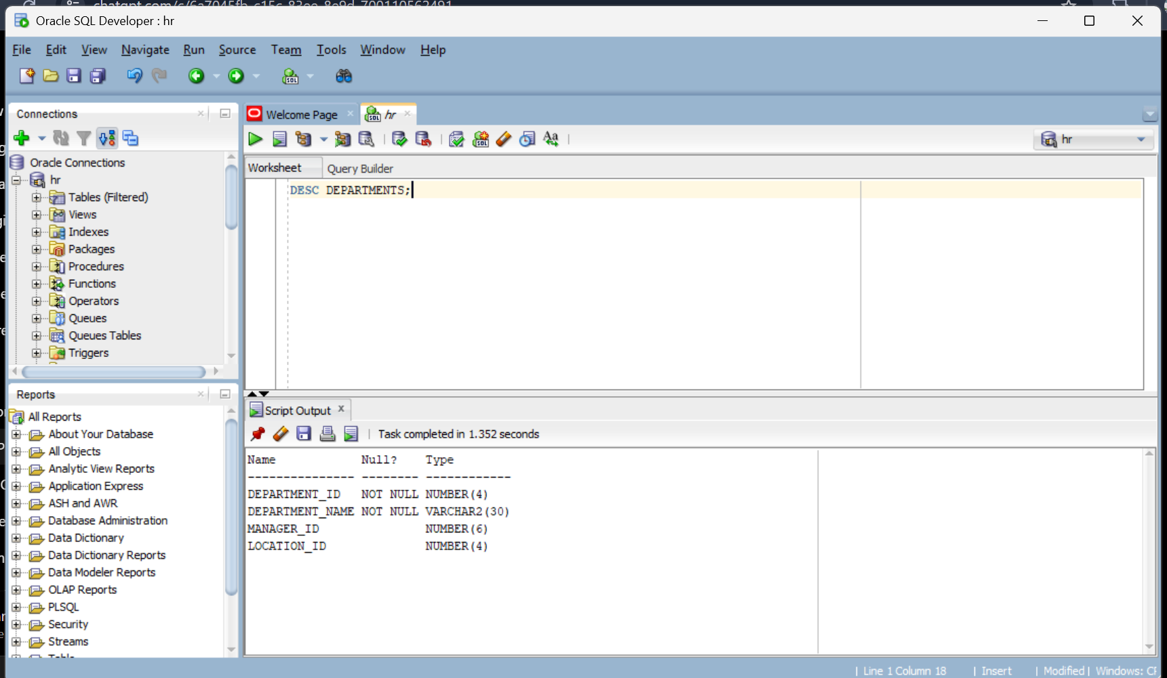

Contents in Table
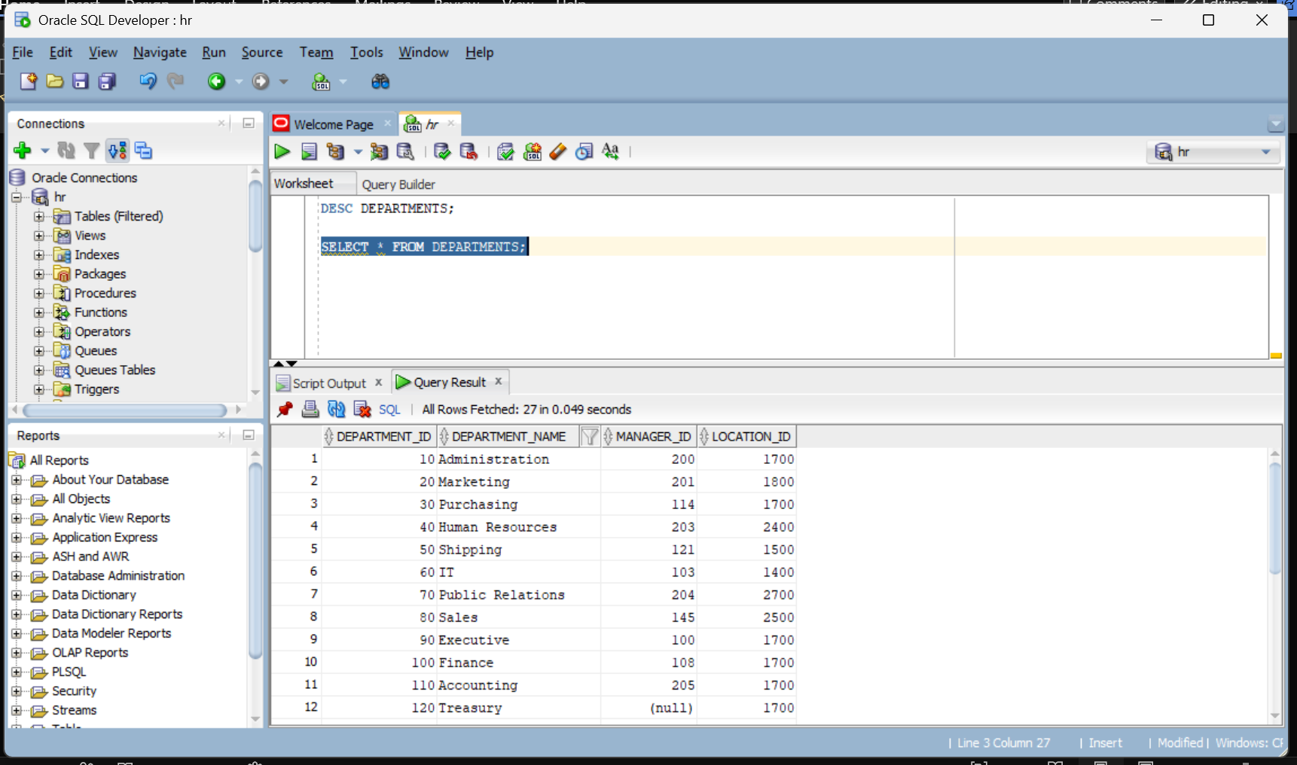

2.Employee Details with Alias
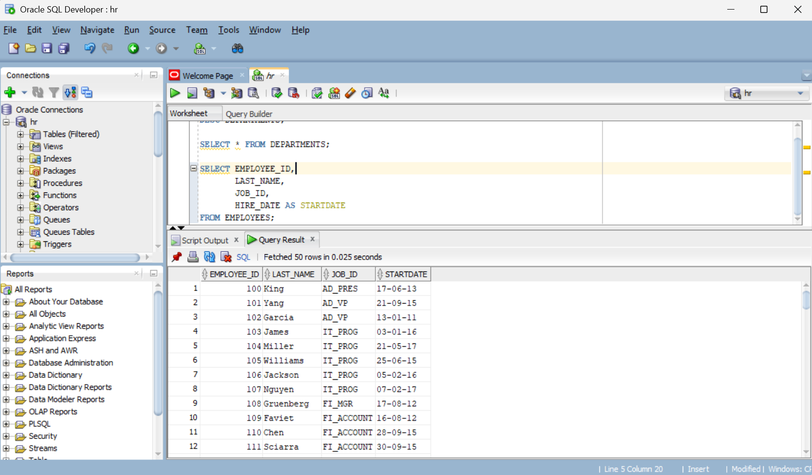

3.Display Of Unique Job IDs
